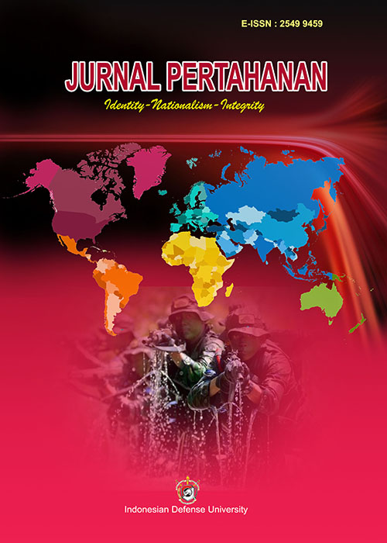
Jurnal Pertahanan: Media Informasi tentang Kajian dan Strategi Pertahanan yang Mengedepankan Identity, Nasionalism dan Integrity
Vol. X No. X (YEAR) pp.XX-XX
https://jurnal.idu.ac.id/index.php/DefenseJournal

Borderlines and Beyond: Strengthening Indonesia’s Land Borders Through Global Insights

First Author^{1*}, Second Author², Third Author³ (Cambria 12, Bold)
^{1,2}Type author’s affiliation here, country (Cambria 11)
³Type author’s affiliation here, country
First Author’s E-mail^{1*}, Second Author’s E-mail², Third Author’s E-mail³
*Corresponding Author

(Due to the double-blind review policy, please add the author’s information only after the acceptance of the peer review process. During submission, the authors only need to input the metadata through OJS.)

Article Info  Article history:  Received : Month Date, Year  Revised : Month Date, Year  Accepted : Month Date, Year  Keywords:  Border management  Neigbouring state  Best practices  Digital transformation  Security systems  DOI:  http://dx.doi.org/10.33172/jp.vxix.xxx | Abstract  Managing border areas shows how serious a country is in maintaining and regulating its territorial boundaries. One sign is the existence of a clear and comprehensive rule of law as a guideline for such management. This research analyzes Indonesia's land border management policy by comparing it to global best practices to formulate a more effective and sustainable strategy. A qualitative approach was taken to examine border management policies in various countries as lessons for Indonesia, by analyzing legal, social, and economic aspects through literature studies. Indonesia's border management shows strengths in law, security and diplomacy, but still faces challenges such as a lack of technological infrastructure. For example, Germany and Poland settled historical claims through bilateral resolutions, while Latvia and Russia opted for international arbitration to resolve border disputes. In mountainous regions such as the Alps (bordering France, Switzerland, Italy and Austria) and the Pyrenees Mountains (France-Spain), countries are implementing aerial surveillance using drones to overcome geographical limitations. Countries like Poland, for example, have successfully tackled the hard-to-reach border in the Białowieża Forest by implementing AI-based smart fences. Indonesia can replicate this approach through digital transformation and the development of technology-based surveillance systems. The implementation of systems such as biometrics and One Post Border System (OPBS) can also speed up the inspection process and strengthen coordination between countries.
2549-9459/Published by Indonesia Defense University This is an open-access article under the CC BY-NC license (https://creativecommons.org/licenses/by-nc/4.0/)

INTRODUCTION
State borders play an important role as a sign of a country's territory to avoid unclear policies and regulations, especially if an event occurs in the area. State borders can take many forms, such as gates, monuments, rivers, seas, or fences. Indonesia has international land borders with three neighbouring countries, Malaysia, Papua New Guinea, and Timor Leste. Meanwhile, Indonesia's waters border ten countries, namely India, Singapore, Malaysia, Thailand, Vietnam, the Philippines, Palau, Australia, Timor Leste, and Papua New Guinea (Sari & Rahman, 2019). Development is a necessity that must be carried out by every nation-state that yearns to realize the dream of overall public welfare. Therefore, the concentration of the implementation of national development programs is not only in urban areas, but must also be oriented towards creating new centers of economic growth, such as border areas. The border area in its development acts as the front porch of the Indonesia, which is a self-mirror and a benchmark for national development (Fachri, 2015; Sudiar, 2015).
Its strategic position makes the development of border areas one of the priorities of national development. Indonesia as an archipelago and has a long border line that is open from everywhere, has potential vulnerabilities due to the difficulty of monitoring border areas and outer islands, especially those bordering neighbouring countries both land, sea, and air. Indonesia and Timor Leste have agreed to establish economic cooperation at the border through cross-border trade facilitated by the Asian Development Bank in 2019 (Rokhanyah, Noor, Harahap, Wijaya, & Amalia, 2023). Support of USD 950,000 to support Indonesia-Timor Leste border cooperation, encouraging trade and tourism between the two countries (Davis, 2019). The construction of Cross Border Posts (PLBN) such as the Motamasin PLBN in East Nusa Tenggara opens up markets that support the economies of surrounding communities by allowing legitimate trade activities between Indonesia and neighbouring countries (Rokhanyah et al., 2023). Then because Indonesia borders Malaysia, Malaysia-Indonesia relations are established bilaterally and through ASEAN, especially through economic cooperation in the ASEAN Free Trade Area (AFTA) which encourages the economic development of both countries (Putra, 2015). Also for example, countries receiving security assistance, such as Lebanon, can improve their ability to manage borders, potentially strengthening relations with donor countries and regional partners (Tholens, 2017).
Border regions often suffer from limited infrastructure, leading to significant economic disparities compared to more centralized areas. This underdevelopment can be seen in various aspects, such as the lack of basic infrastructure, low community welfare, and limited access to quality education and health services. Geographical factors dominated by hills mean that these areas can only be reached by pioneering aircraft or special boats capable of crossing swift-flowing rivers (Sudiar, 2015). From a development perspective, border communities tend to be marginalized and less empowered to deal with potential threats (Budi & Ratmono, 2018). In addition, ongoing border disputes with neighbouring countries further complicate governance and resource allocation in the region. Also border regions often experience heightened security risks due to geopolitical tensions and military conflicts, as seen in Jammu and Kashmir, India (Khan & Shameem, 2024). To address these challenges, special autonomy is proposed with the aim of implementing development policies that are more specific to the needs of border communities (Permatasari, 2014). However, some argue that an emphasis on border security and control can actually enhance cooperation between the state and communities and strengthen community resilience to external threats (Missbach, 2014).
This research focuses on analyzing policies for managing and strengthening Indonesia's land borders by adopting various global perspectives, compare Indonesia's border policies with best practices from various countries to identify strategies that can be implemented. Based on the analysis, this research will develop policy recommendations that can improve border management more effectively, sustainably, and competitively in a global context. This study specifically uses a literature review approach by reviewing various regulations, research reports, scientific journals, and case studies from countries that have experience in managing land borders.

METHODS
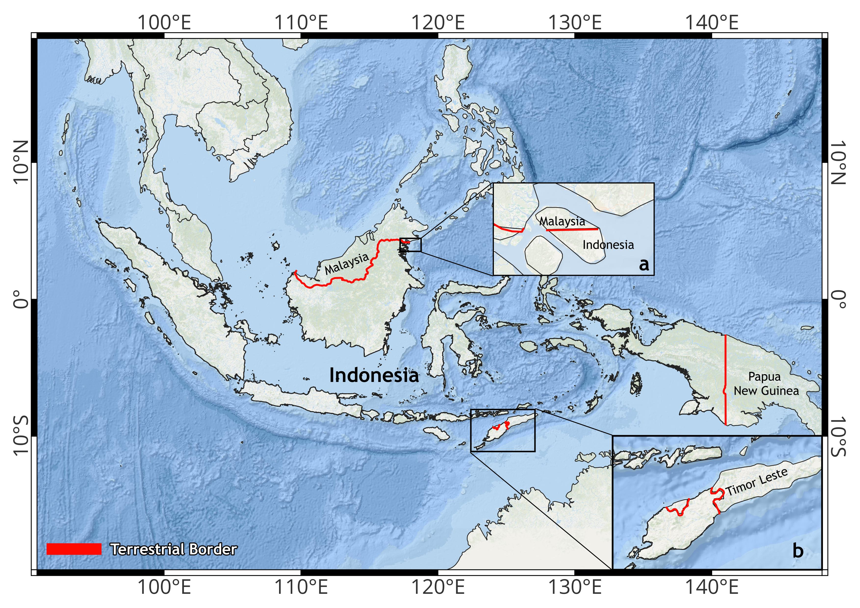
Figure 1. Indonesia's terrestrial borders with neighbouring countries
The study area covers all of Indonesia's terrestrial borders with neighbouring countries (Figure 1). West Kalimantan, East Kalimantan, and North Kalimantan provinces border Sarawak and Sabah, Malaysia. Near North Kalimantan, precisely on Sebatik Island (inset a), Indonesia also borders Malaysia. In the south (inset b), East Nusa Tenggara Province borders Timor Leste. In eastern Indonesia, Papua Province borders Papua New Guinea.
A qualitative approach was undertaken to review how border management policies in various countries around the world can serve as examples for Indonesia's border management. The identification of border management in the legal, social, and economic dimensions was conducted through existing literature. The results obtained were compared to identify the existing challenges and how countries around the world address them in the context of border management, and to investigate how they relate to the conditions in Indonesia.
The literature that serves as the source includes legal frameworks such as national security policies and border management laws, both from Indonesia and other countries. Official reports from agencies related to border management, both from Indonesia (e.g. BNPP and Ministry of Foreign Affairs) and international agencies (e.g. UN and ASEAN). In addition, peer-reviewed journal articles are also used to understand how countries around the world manage their borders to be used as case studies.
The criteria for the border management case study were selected using three main criteria. First, countries that have areas with multi-layered border management due to socio-economic or political divisions. Second, border areas with disputes among several parties, whether ongoing or resolved. Third, countries that have implemented effective management concepts to address these issues. The three criteria were chosen so that the existing case studies were relevant to the Indonesian context.

RESULT
Indonesia's Land Border Management Policy
Indonesia implements various policies in land border management to maintain national sovereignty and security. Based on data from the National Border Management Agency (BNPP), there are 187 sub-districts in 54 districts or cities that directly border other countries, with special regulations covering immigration, trade and defense aspects (Kennedy, 2021). Immigration is tasked with overseeing the crossing of people at the 10 main Cross Border Posts (PLBN), while Customs oversees the entry and exit of goods to prevent smuggling. The Indonesian National Armed Forces and Indonesian National Police deploy more than 2,500 border personnel to maintain security, especially in conflict-prone areas such as the Indonesia-Malaysia border in Kalimantan and Indonesia-Papua New Guinea (Uly, Harsono, Supriyatno, & Gultom, 2023). Indonesia has implemented various policies and regulations to strengthen border area governance. These policies include cross-border surveillance, infrastructure development, improving the welfare of border communities, and inter-agency coordination. The following Table 1 summarizes various important regulations issued from 1985 to 2020, which serve as a legal basis for the management of Indonesia's land borders.

Table 1. Regulations issued between 1985 and 2020 that serve as the legal basis for Indonesia's land border management
No | Regulation | Content | Description
1 | Law No. 43 Year 2008 on State Territory | Regulate the boundaries of Indonesia's land, sea and airspace | Legal basis of territorial sovereignty
2 | Law No. 26 Year 2007 on Spatial Planning | Regional spatial planning including border areas | Supporting development and defense
3 | Law No. 6 of 2014 on Villages | Management of villages in border areas, especially those that are underdeveloped and outermost | Focus on empowering border villages
4 | Presidential Regulation No. 179 Year 2014 on National Border Management Agency | Organizing the duties and functions of the National Border Management Agency | Cross-sector coordination of border areas
5 | Government Regulation No. 62 Year 2010 on Small Outer Islands | Management and protection of small outer islands | Maintain the territorial integrity of the Republic of Indonesia
6 | Presidential Regulation No. 18 of 2020 on Medium-Term National Development Plan 2020-2024 | Development of border areas as a national priority | Related to infrastructure and basic services
7 | Law No. 32 Year 2014 on Maritime Affairs | Management of marine areas, security, and marine resources | Regulate the EEZ, continental shelf, etc
8 | Law No. 17 Year 1985 on UNCLOS 1982 | Ratify the UN Convention on the Law of the Sea | Basis for Indonesia's international maritime claims
9 | Presidential Decree No. 6 Year 2017 on the Map of the Republic of Indonesia | Establishment of an official map of the Indonesian territory | Reference in regional governance
Table 1. contains some examples of rules and regulations governing the management of Indonesia's borders. Indonesia has established a comprehensive legal and regulatory framework to effectively manage its border areas. Some of the key regulations include Law No. 43/2008 on State Territory that regulates Indonesia's land, sea and air borders, and Law No. 26/2007 on Spatial Planning that ensures border areas are included in the national development strategy. The management of border villages is supported by Law No. 6/2014, while Presidential Regulation No. 179/2014 regulates the coordinative role of the National Border Management Agency (BNPP). The integrity of the outermost regions is affirmed through Government Regulation No. 62/2010 on the Outermost Small Islands, and the strategic development of border areas is directed by Presidential Regulation No. 18/2020 on the RPJMN 2020-2024. In the maritime context, Law No. 32 of 2014 on Maritime Affairs and Law No. 17 of 1985 ratifying UNCLOS 1982 affirm Indonesia's sovereignty and rights over its maritime territory. Finally, Presidential Decree No. 6/2017 establishes an official map of the territory of the Republic of Indonesia that serves as a reference in governance and planning. All of these policies support a holistic approach to border management, sovereignty and sustainable development.
In order to maintain the sovereignty and stability of its border areas, Indonesia does not only rely on domestic policies, but also establishes various forms of cooperation with other countries. This cooperation includes bilateral and multilateral agreements that aim to resolve border issues, strengthen security, and encourage development in border areas. Table 2. below summarizes Indonesia's main regulations and collaborations related to border management and foreign relations.

Table 2. Indonesia's border regulations and cooperation with foreign countries
No | Regulation and Collaborations | Content | Description
1 | Law No. 37 Year 1999 on Foreign Relations | Sets out Indonesia's principles and policies in establishing foreign relations | Basis for bilateral and multilateral cooperation, including border issues
2 | Law No. 24 Year 2000 on International Agreements | Procedures and requirements for making international agreements, including state border agreements | Organize the ratification and implementation of foreign treaties
3 | Presidential Regulation No. 34 Year 2010 on Border Management Cooperation Forum | Encourage bilateral cooperation in border areas, such as with Malaysia, PNG, and Timor Leste | Facilitate border diplomacy and development
4 | Joint Border Committees (JBC) | Bilateral forums between Indonesia and neighboring countries to resolve boundaries | Routinely conducted with Malaysia, Timor Leste, and Papua New Guinea
5 | Trilateral Cooperation Indonesia–Malaysia–Philippines | Maritime security cooperation in border areas, especially in the Sulu and Sulawesi Seas | Focus on preventing terrorism, smuggling and cross-border crime
6 | Indonesia-Timor Leste Border MoU (2005, 2013, etc.) | Land border agreements, joint patrols, and cross-border infrastructure development | There are still boundary segments that have not been agreed upon
7 | Collaboration in Border Trade Agreement (BTA) | Cross-border trade agreements, such as in Entikong (Indonesia-Malaysia) | Improving the economy and welfare of border residents
8 | UNCLOS 1982 (ratified by Law No. 17 of 1985) | Form the basis for international cooperation on maritime boundaries, EEZs and continental shelves | Primary reference in maritime boundary negotiations with other countries
Table 2. presents various regulations and forms of international cooperation carried out by Indonesia in the context of border area management. Regulations such as Law No. 37 of 1999 on Foreign Relations and Law No. 24 of 2000 on International Agreements provide a legal basis for building bilateral and multilateral relations, including in the context of resolving border issues. In addition, there is concrete cooperation such as Joint Border Committees with Malaysia, Timor Leste, and Papua New Guinea (Armita Arvanti, Bayu Setiawan, Syamsunasir, & Pujo Widodo, 2023; Mangku, 2020). The Indonesia-Malaysia-Philippines trilateral cooperation is focused on securing border maritime areas, particularly in the Sulu Sea and Sulawesi Sea. This collaboration aims to prevent transnational threats such as terrorism, smuggling and other maritime crimes through joint patrols and security coordination (Febrica, 2014; van Zundert, 2022). Collaboration in a Border Trade Agreement (BTA) is a form of cross-border trade agreement, such as the one implemented in Entikong between Indonesia and Malaysia. The main objective of this cooperation is to improve the economy and welfare of people living in border areas through more open and regular trade access (Niode, Rachman, & Waworundeng, 2022; Sarjono & Rudiatin, 2022). Through this cooperation, Indonesia seeks to strengthen border diplomacy, improve regional security, and support the welfare of border communities.

Institutional Role
In the context of border area management, Indonesia involves various institutions and elements of society that have strategic and complementary roles. Border management is not only about security aspects, but also includes monitoring the flow of goods and people, law enforcement, and socio-economic development of border communities. Therefore, institutions such as the National Border Management Agency (BNPP), Immigration, Customs, Indonesian National Armed Forces (TNI), Indonesian National Police (Polri), and together with local governments and local communities, work together in an integrated manner to maintain state sovereignty and promote prosperity in border areas.
Indonesia have a main cross-sector coordinator in the management of border areas, including the physical, social and economic development of border communities, namely BNPP. They manage both state borders, including state border crossings, as well as border areas (Seran, 2022). Based on the mandate of Law of the Republic of Indonesia Number 43 of 2008, state borders, both State Territorial Boundaries and Border Areas, are managed by BNPP (Mangku, 2019; Redjo & As’ari, 2017). BNPP is led by the Minister of Home Affairs as the Head of BNPP RI and is responsible to the President of Indonesia. BNPP carries out, among other things, the construction and management of the Cross Border Post (PLBN) in Nanga Badau, West Kalimantan, which borders Malaysia (Firdaus, 2019). Immigration agencies are tasked with overseeing the entry and exit of people, issuing travel documents (passports), and preventing the entry of illegal foreigners or human trafficking. The Border Control Management (BCM) system is a technology used by the Indonesian government to monitor the entry and exit of people at border areas through immigration checkpoints. In the field, such as at PLBN Motamasin in East Nusa Tenggara, this system is supported by the active role of officers who become liaisons between the Indonesian immigration authorities and neighbouring countries (Jade, 2022). They work together to deal with illegal immigrants, including by applying immigration law measures against foreigners who violate the rules. (Maria Vianey Gunu Gokok, Tanti Nurgiyanti, Diansari Solihah Amini, & Yeyen Subandi, 2023).
Customs plays an important role in overseeing the cross-border movement of goods to prevent smuggling and trade violations. At the Pos Lintas Batas Negara (PLBN), Customs officers are tasked with inspecting luggage and cargo to ensure compliance with import and export regulations (Rokhanyah et al., 2023). In addition, they also coordinate with other agencies such as the TNI, Polri, and Immigration in maintaining security and order in border areas, especially in vulnerable areas such as the Indonesia-Timor Leste and Indonesia-Malaysia borders. The Atambua Customs and Excise has tightened supervision at PLBN Motaain in East Nusa Tenggara Province to prevent smuggling of goods, such as subsidized fuel oil to Timor Leste (Leonita et al., 2024).
BNPP also collaborating with the Ministry of Public Works and Public Housing (PUPR), the Directorate General of Immigration, the Directorate General of Customs and Excise, the Indonesian National Army (TNI), and the Indonesian National Police (Polri) in developing an integrated Cross-Border Post (PLBN). This effort aims to strengthen the surveillance function and increase the economic activities of border communities. The development of PLBN is also accompanied by a welfare-based approach, such as revitalizing people's markets and empowering Micro, Small and Medium Enterprises (MSMEs) through training and technical guidance (Ulut, Amitran, & Foenay, 2023). In this case, it appears that all institutional presences have roles that emphasize not only security aspects, but also socio-economic development as a comprehensive solution to border issues.

International Comparison
In dealing with complex global border issues, countries have adopted different policies and strategies, depending on the historical, political and social context. For example, the United States and Mexico attempt to manage border issues through bilateral agreements, infrastructure development such as border walls, and security cooperation, although different political approaches often become obstacles. Meanwhile, the India-China border conflict is handled through diplomatic dialogue and high-level military meetings, although it has yet to result in a final settlement. These strategies reflect the importance of multilateral approaches and sustainability in addressing border conflicts peacefully and fairly.

Table 3. Selected global border conflicts and resolutions
Border | Problem | Resolution | Reference
Germany - Poland | Historical claims | Bilateral resolution | (Schmidtke, 2023)
Latvia - Russia | Historical claims | International arbitration | (Krumiņš, 2017)
The Alps (France-Italy-Switzerland-Austria) & The Pyrenees (France-Spain) | Mountainous areas (hard to reach) | Aerial surveillance and drone technology | (Marin & Krajčíková, 2016a; Toribio, 2023)
The Białowieża Forest (Poland-Belarus Border) | Hard to reach areas (wildwood) | Smart Fencing with AI Monitoring | (Marin & Krajčíková, 2016a)
Chile - Peru | Territorial disputes over the maritime boundary and coastal territories | Peace Treaty of 1929 and International Court of Justice (ICJ) ruling in 2018 | (Sholikah, 2020)
USA – Mexico | Border security issues, migration, and drug trafficking | Bilateral agreements; border wall initiatives; ongoing tensions | (Slack & Martinez, 2019)
India - China | Long-standing territorial dispute over Aksai Chin and Arunachal Pradesh | Ongoing diplomatic talks; military standoffs persist | (Verma, 2024)
 | Competing national claims over land including West Bank, Gaza, and Jerusalem | Ongoing conflict; partial accords; unresolved sovereignty | (Aammari, 2020)
  Israel - Palestine

Table 3, contains some of the cases and conflicts that occur at the borders of countries in the world. Border issues are solved in different ways, depending on each country's location and political situation. Germany and Poland settled their border disagreements through direct talks, leading to the German-Polish Border Treaty of 1990, which confirmed the Oder–Neisse line as their official border. Earlier agreements, such as the Treaty of Warsaw (1970) and the Treaty of Zgorzelec (1950), helped build understanding, but a final decision was only made after Germany reunited. Their cooperation grew stronger with the 1991 Treaty on Good Neighbourliness, which helped improve political and economic relations (Schmidtke, 2023), Latvia and Russia settled their border disputes through international arbitration, making the decisions legally binding. The 2007 Latvia-Russia Border Treaty, reached through diplomatic and legal talks, resolved territorial claims, especially over Abrene (Pytalovo). This method helped set a clear and agreed-upon border while reducing the risk of future conflicts with international supervision (Krumiņš, 2017). In mountain areas like the Alps and Pyrenees, countries use aerial surveillance and drones for efficient border monitoring. These technologies help track movements in real time and enable quick responses to security threats, overcoming the challenges of rough terrain. This method enhances border security while reducing reliance on ground patrols in hard-to-reach areas (Toribio, 2023). Poland and Belarus have implemented smart fencing with AI monitoring in the Białowieża Forest to improve border security while protecting the environment. This system uses sensors and machine learning to detect unauthorized crossings and instantly notify authorities. By reducing the need for physical barriers, this approach ensures both security and ecological conservation (Marin & Krajčíková, 2016b). The Chile-Peru border issue stems from post-Pacific War territorial disputes, particularly over Arica and the maritime border. Although partially resolved through the 1929 Peace Treaty, the maritime dispute was only truly settled by a 2014 International Court of Justice (ICJ) ruling that established the maritime boundary between the two countries (Sholikah, 2020). These approaches show that a combination of diplomacy and technology can be an effective solution in land border management, which can be adapted to strengthen Indonesia's border security.
However, there are some border issues that are still in conflict today, or unresolved, such as in the case of the United States and Mexico where the root of the problem is structural and multidimensional, with differing political approaches between the two governments often impeding a comprehensive long-term solution (Liverman, Varady, Chavez, & Sanchez-Rodriguez, 1999; Slack & Martinez, 2019). The India-China conflict is ongoing as both countries have conflicting historical and strategic claims, and there is no mutually agreed official border line (Tasik, Setiawan, Widirahayu, & Saleh, 2023; Verma, 2024). Then, the Israeli-Palestinian conflict is still ongoing because the two parties have not agreed on a two-state solution, and key issues such as the status of Jerusalem, legal borders, Palestinian refugees, and illegal Israeli settlements in the West Bank have not been resolved. In addition, internal political tensions and recurring cycles of violence complicate the peace process. (Aammari, 2020; Hildebrandt-Wypych, 2022; İNAÇ, 2024). In this case it can be seen that complex root causes, political differences, and internal tensions can hinder problem solving. Long-term solutions require mutual commitment, open discussion, and fair options for all parties.

DISCUSSION
Strengths and Weaknesses of Indonesia's Border Management
The numerous border areas that Indonesia must monitor and manage have resulted in many efforts being made to maintain peace and security in those areas. The efforts that have been made strengthen Indonesia's border management. However, there are still weaknesses that need to be addressed in Indonesia's border management. The evaluation of these strengths and weaknesses can be examined from five sectors, namely legal and institutional framework, security surveillance, cross-border economic development, and diplomatic engagement. The four sectors are sufficient to represent the effectiveness of Indonesia's border management.
The first sector, legal and institutional framework, provides fundamental legal certainty regarding Indonesia's border management activities. For example, BNPP was established based on Article 14 of Law Number 43 of 2008 concerning State Territory, which mandates the formation of a special institution to manage border area affairs. BNPP is present to ensure the implementation of relevant laws regarding borders. In addition, BNPP also has the authority to coordinate agencies in Indonesia in handling complex border issues. Legal products also provide clear mandates for each agency in Indonesia regarding their duties and authorities in the context of border management. The clear delineation of duties and authorities for each agency ensures there is no overlapping between agencies, such as between customs and immigration.
This sector also provides clarity on international borders through bilateral agreements, such as the demarcation of terrestrial borders between Indonesia and East Timor in 2005. The existence of a framework on bilateral cooperation mechanisms also ensures clear standards related to dispute resolution and border-crossing procedures. Indonesia has agreed to establish cooperation with Malaysia and Timor-Leste for the resolution of border disputes through diplomatic channels. In addition, there are also Memoranda of Understanding (MoUs) between Indonesia and neighbouring countries that regulate the procedures for the public if they wish to cross the border between countries.
Besides the framework's coverage in several areas, this sector faces challenges in its implementation. Legal products and inter-agency agreements, both within Indonesia and with other countries, have explained what should be done in border areas. However, the challenging geographical conditions of these border areas often make them isolated, leading to inconsistent law enforcement. The existing legal products and frameworks have not yet resolved all the existing issues, either due to lengthy legal processes or the lack of agreements between the disputing parties. The process of negotiating the demarcation of the EEZ with East Timor is an example where a lengthy negotiation process resulted in a gray area, a disputed region with low law enforcement due to the ambiguity of who is responsible for this territory. Inconsistent law enforcement makes this gray area vulnerable to uncontrolled natural resource exploitation, resulting in biodiversity degradation.
The second sector, security surveillance, ensures continuous and intensive monitoring in border areas. Physical demarcation has been widely implemented in Indonesia's border areas with the aim of providing clear boundaries regarding national borders. In line with the physical demarcation, border posts are also built in selected areas that serve as entry and exit points between countries. The continuous improvement of border posts by the Indonesian government ensures thorough supervision, such as immigration and customs checks.
The presence of active military, the Indonesian National Armed Forces (TNI), and police at every border post also provides a certain strength to security surveillance in Indonesia's border areas. The presence of TNI members and police at border posts ensures a first response to threats that endanger national security and sovereignty. They also become actively involved in joint patrols in border areas with other countries to anticipate cross-border crime. Routine border patrols conducted by trained military personnel provide a higher level of assurance in responding to crimes occurring in border areas.
Insufficient supporting technology infrastructure is one of the weaknesses in border management in this field. The absence of a smart border system that can detect crimes and threats becomes an obstacle in sustainable real-time monitoring. The absence of drones forces patrol personnel to move across vast areas periodically. The lack of thermal imaging at border posts makes nighttime surveillance very challenging. The lack of implementation of these technologies forces personnel to conduct manual patrols, which are time-consuming and costly. The small number of military personnel stationed at these border posts exacerbates law enforcement in border areas. The small number of personnel and traditional patrolling processes mean that many areas are not monitored, providing opportunities for cross-border crime to occur. The lack of supporting technology implementation at border posts also results in inspections of individuals leaving or entering the country having to be done manually. This manual process takes a long time, so if there are many parties that need to be inspected, the work that immigration officers and other relevant officials have to do requires a lot of time and effort.
Developments in the cross-border economic development sector provide an overview of how border management can contribute to local and national economic growth. The existence of a bilateral agreement between Indonesia and neighboring countries regarding the commitment to facilitate economic growth in border areas provides a unique strength to Indonesia's border management. Entikong International Border Post in West Kalimantan is an example of a border post located within special border economic zones (SBEZs), an area resulting from the Indonesia-Malaysia bilateral cooperation that has special characteristics such as duty-free trade to encourage cross-border commerce. The existence of special areas like SBEZs makes it easier for sellers and buyers to conduct their business because there are several special treatments, allowing the economic activities in border areas to run smoothly.
Nevertheless, the geographical and economic conditions pose significant challenges that must be addressed wisely. The condition of the road network, which is not yet fully developed, tends to hinder economic growth because roads are one of the most important infrastructures in logistics. Many border areas are also geographically isolated, such as in East Kalimantan and Papua, making it more difficult to develop road networks. Although there are other options such as logistics distribution via air routes, this choice is too expensive for most of the community. This is mainly because of the wide socio-economic gap between the border regions and the surrounding city centers. Economic improvement through private sector investment in these areas is also difficult to achieve due to the minimal and limited financial incentives.
In the sector of diplomatic engagement, diplomacy between Indonesia and other countries is extensively conducted to find solutions to existing problems. These bilateral and/or multilateral agreements cover a wide range of issues, such as negotiations on land boundary demarcation and commitments to conduct joint patrols in border areas. In addition, the ratification of international frameworks, such as the United Nations Convention on the Law of the Sea (UNCLOS), into national law also ensures the presence of internationally recognized standard rules in Indonesia. The frameworks provide significant contributions to bilateral and/or multilateral dispute negotiations between Indonesia and other countries.
Although there are frameworks that guide how disputes can be resolved, the commitment to negotiate remains key in settling those disputes. Differences in desires and interests between the disputing parties make the negotiation process lengthy. This lengthy process ultimately makes the gray zone increasingly susceptible to abuse, as previously explained. The absence of a standardized early-warning system in border areas results in limited conflict prevention. Furthermore, the lack of public transparency regarding the developments in border disputes, which has not been widely implemented, triggers a decline in public trust.

Best practices from other countries
The challenges of legal and institutional frameworks and diplomatic engagement are also present in European countries. They have heavily relied on bilateral agreements and international arbitration to resolve disputes related to their border management. The German–Polish Border Treaty is the result of resolving disputes related to the demarcation of the post-WWII border between Germany and Poland through a diplomatic approach (Gorzelak, 2016). Many historical claims about the border line between the two countries after WWII could trigger conflicts in the future. The commitment of both countries to resolve the issue, which ultimately resulted in the German–Polish Border Treaty, eliminated the potential for conflict. Overlapping claims regarding national borders based on past conditions also occur between Latvia and Russia. Historical claims became the main reason for the tension between the two countries, which ultimately used international arbitration as a solution.
In addition to the challenges of the legal and institutional framework, the geographical conditions of Europe also pose significant challenges to border management there. The border between France, Italy, Switzerland, and Austria in the Alps has an extreme landscape with steep mountains with extreme changes from climate change, making physical demarcation difficult, let alone conventional patrolling (Huss, Hock, Bauder, & Funk, 2010; Zampieri, Scoccimarro, Gualdi, & Navarra, 2015). This is exacerbated by harsh weather conditions with the risk of avalanches, fog, and such. Hidden valleys and rugged paths also make cross-border crime very difficult to detect.
Switzerland have successfully leveraged technological advancements to tackle this challenge where they implemented aerial monitoring using drones so that those extreme areas could be monitored effectively (Pedrozo, 2017). The installation of thermal imaging on those drones also makes the detection of crimes easier because no matter how good the camouflage used by criminals, it will still be visible to the thermal imaging technology. These countries have also committed to conducting joint patrols in hard-to-reach areas to reduce crimes there. This joint patrol also allows for the sharing of technology and information among these countries, enabling the first response to incidents to be as quick and precise as possible.
Wilderness forests are also commonly found in Europe, and many of the border regions are located within these forests. The Białowieża Forest is an example of a forest on the border between Poland and Belarus that poses significant challenges for the border management of both countries (Nowak et al., 2025). The dense and vast forest makes physical law enforcement very difficult and high-risk. The location of the forest, situated between two cities, and the difficulty of physical law enforcement make it easy for many smugglers and illegal immigrants to use the Białowieża forest as a route to enter and/or exit both countries undetected. Ecological concerns also hinder law enforcement because heavy infrastructure would certainly degrade the biodiversity in the forest.
Technology has become the frontline in helping to address the challenges present in the forest area (Świerczyńska, 2023). Poland has an observation tower equipped with high-definition cameras and motion sensors to monitor activities occurring. A high steel border wall equipped with AI-assisted surveillance has also been built to detect activities in real-time. The unique aspect of border management between Poland and Belarus is that they have agreed to implement environmentally friendly border management with the aim of balancing security with ecosystem protection. This commitment demonstrates mature multisectoral-based decision-making so that law enforcement and security can run in parallel with environmental protection.

Proposed Modifications for Indonesia’s Border Management
Based on the previous discussion, there are several points proposed for Indonesia's border management. Determining the settlement of border disputes as a national strategic issue is the main foundation for overcoming the challenges of the legal and institutional framework and diplomatic engagement that result in a gray zone in the border area. Indonesia can work together with neighbouring countries to establish a bilateral negotiation roadmap that serves as a basis for resolving time-bound border disputes, as done by Norway and Russia in resolving their Arctic maritime border. Establish a joint legal review committee with Malaysia, Timor Leste, and Papua New Guinea to ensure a common understanding and to avoid misinterpretation.
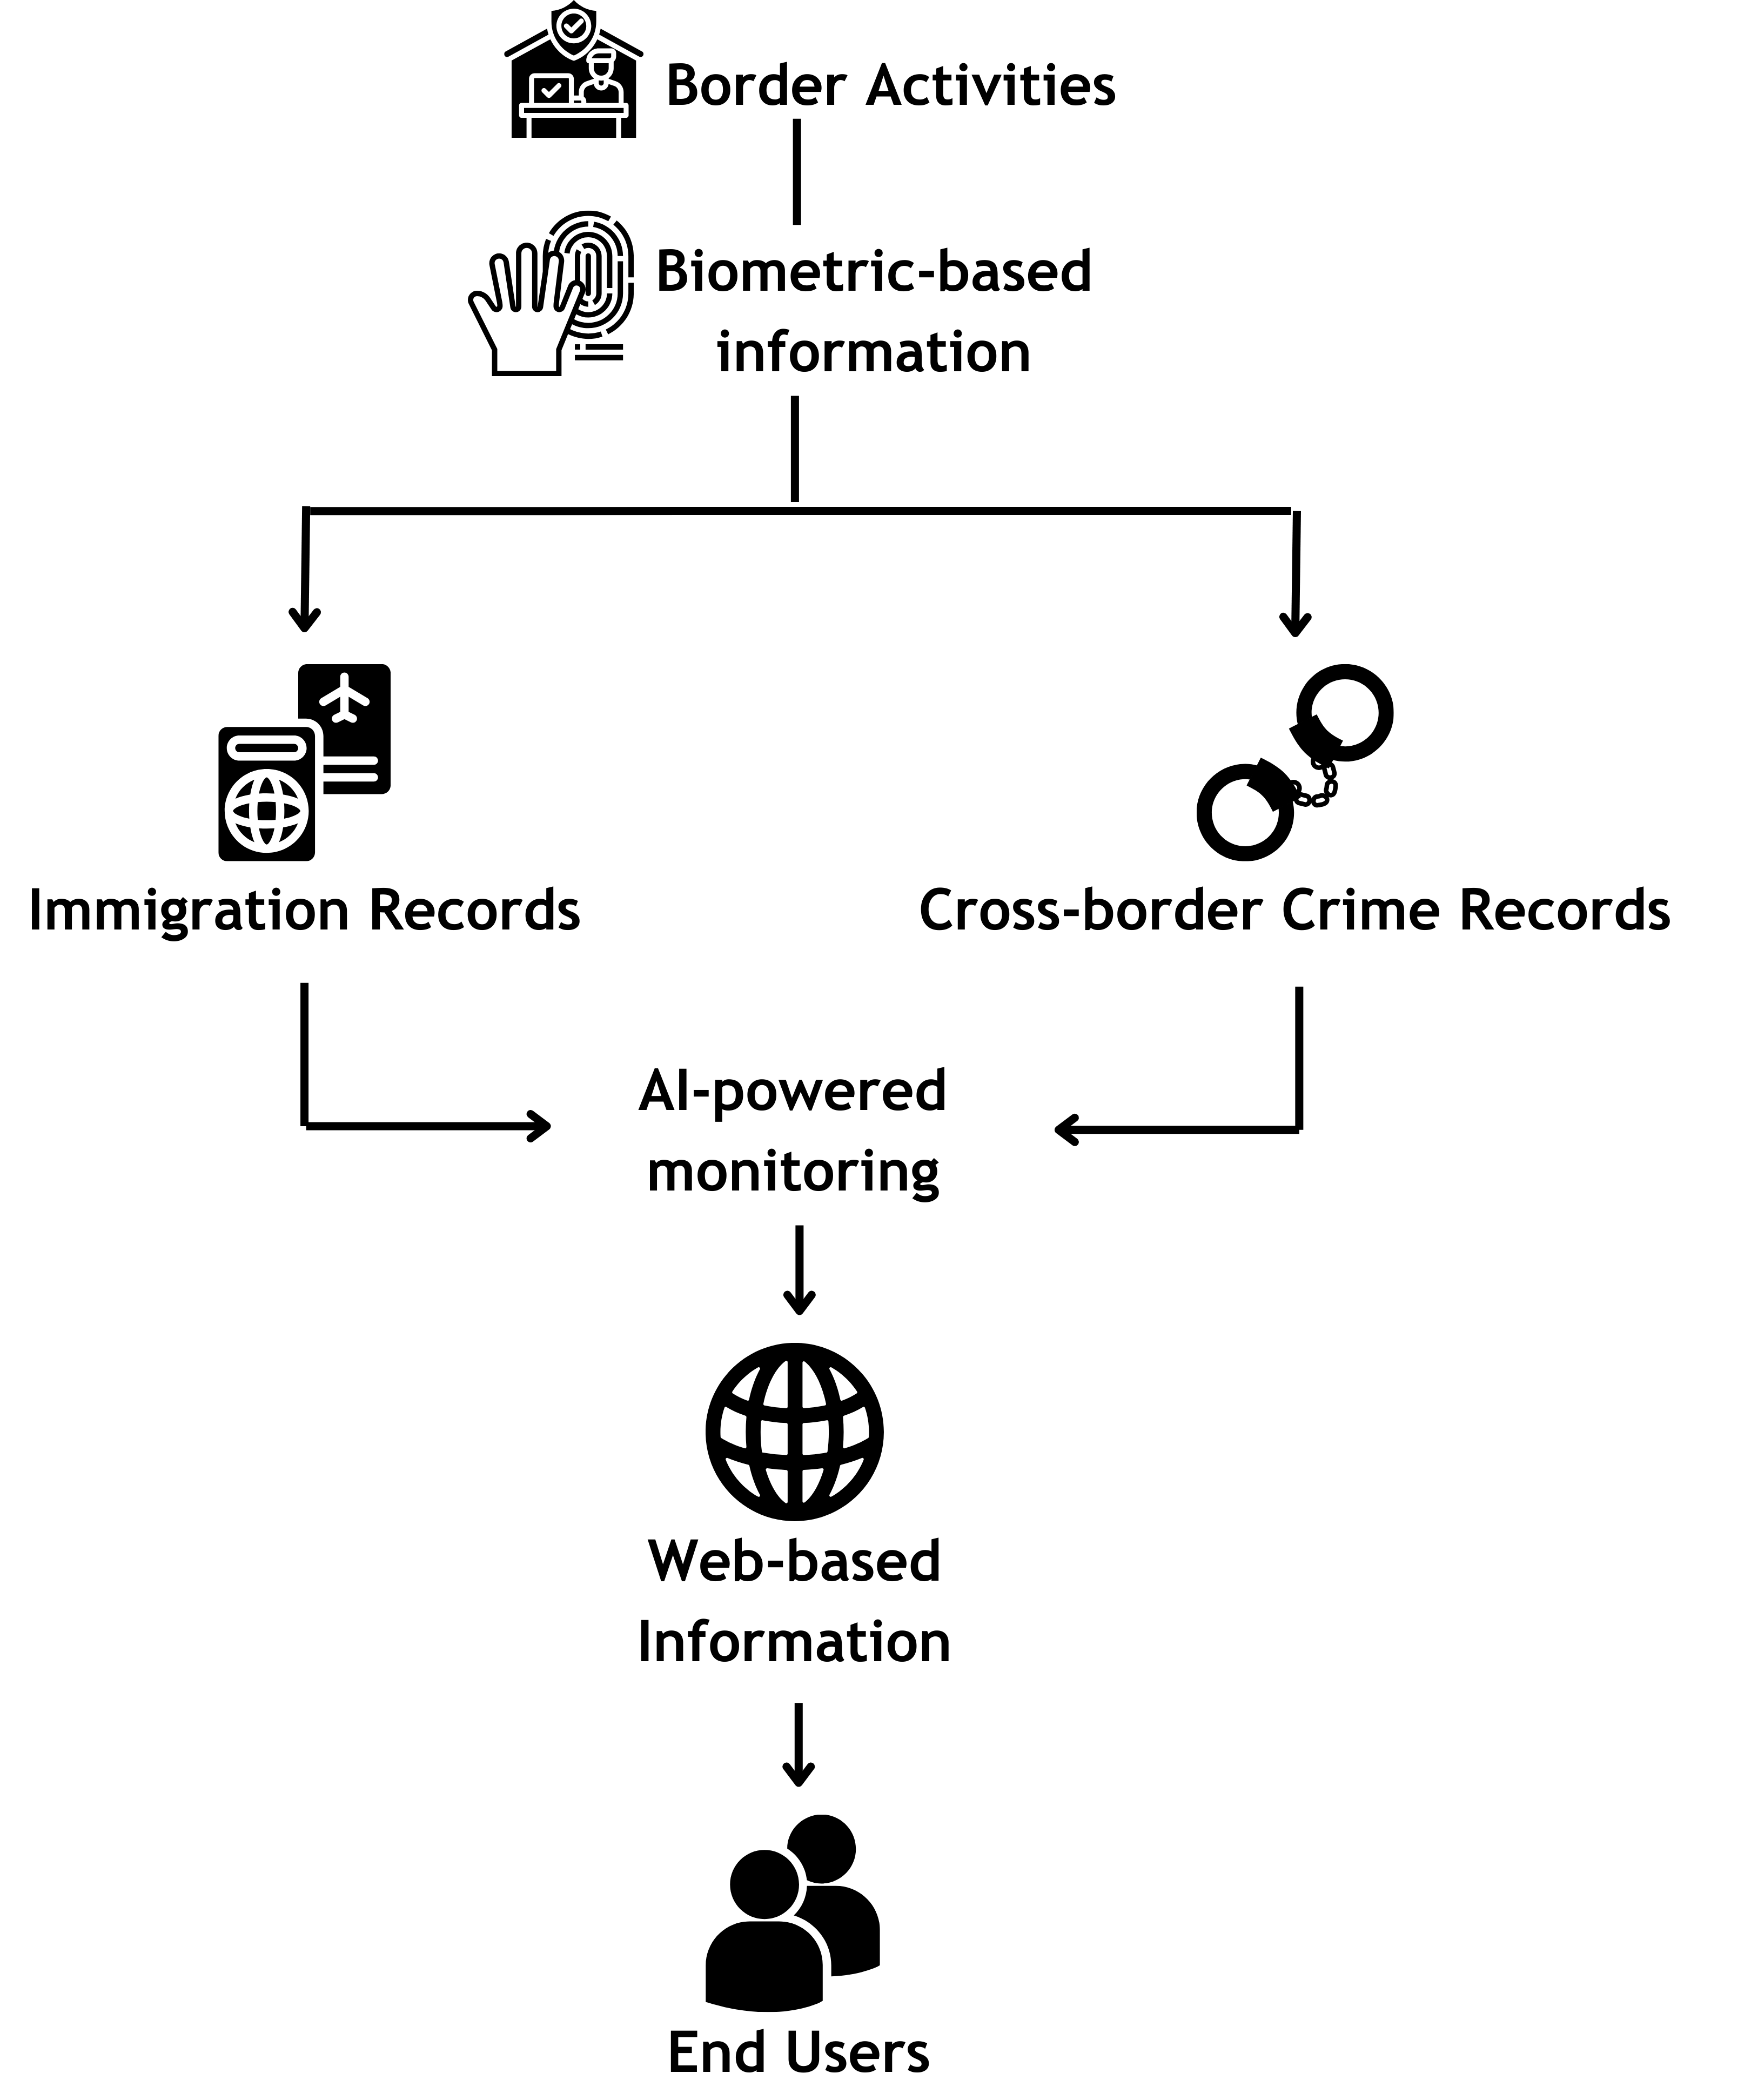
Figure 2. Digital Transformation of Border Information System Concept
Digital transformation in border areas (Figure 2) has provided significant progress for border management in Indonesia. Border control that still relies on paper makes administrative processes slow at checkpoints. The presence of digital and biometric-based input ensures that the information processed is accurate and integrated with other information systems. Biometric-based information also makes identity forgery more difficult because the information checking process is carried out in a multi-layer manner, compared to databases from relevant agencies. Activities carried out by a particular person, be it immigration records or crimes committed, will be linked to their biometric information. This means that this information will continue to appear when the person's biometric information is checked. The application of Artificial Intelligence (AI) in this system provides comprehensive supervision. AI acts as a tool to analyze dynamics in border areas, at least by automatically identifying the track records of people entering and/or leaving Indonesia. This information is also collected on a website dedicated specifically to activities in border areas. Ultimately, this system can be accessed by the public to find out how their border areas are developing. In addition, relevant agencies can also access this website to obtain specific and more detailed information. This digital transformation maintains public trust in Indonesia's border management and ensures information sharing between institutions, thereby eliminating misinformation between them.
One Post Border System (OPBS) combined with digital transformation can also simplify the process at checkpoints. OPBS is a system where officers from both countries at border posts work together so that checks from both countries can be carried out directly in the same place. This system also ensures effective communication between officers so that the first response process to existing incidents can be carried out effectively. Border posts with OPBS also become the main command center in joint patrol activities in border areas.

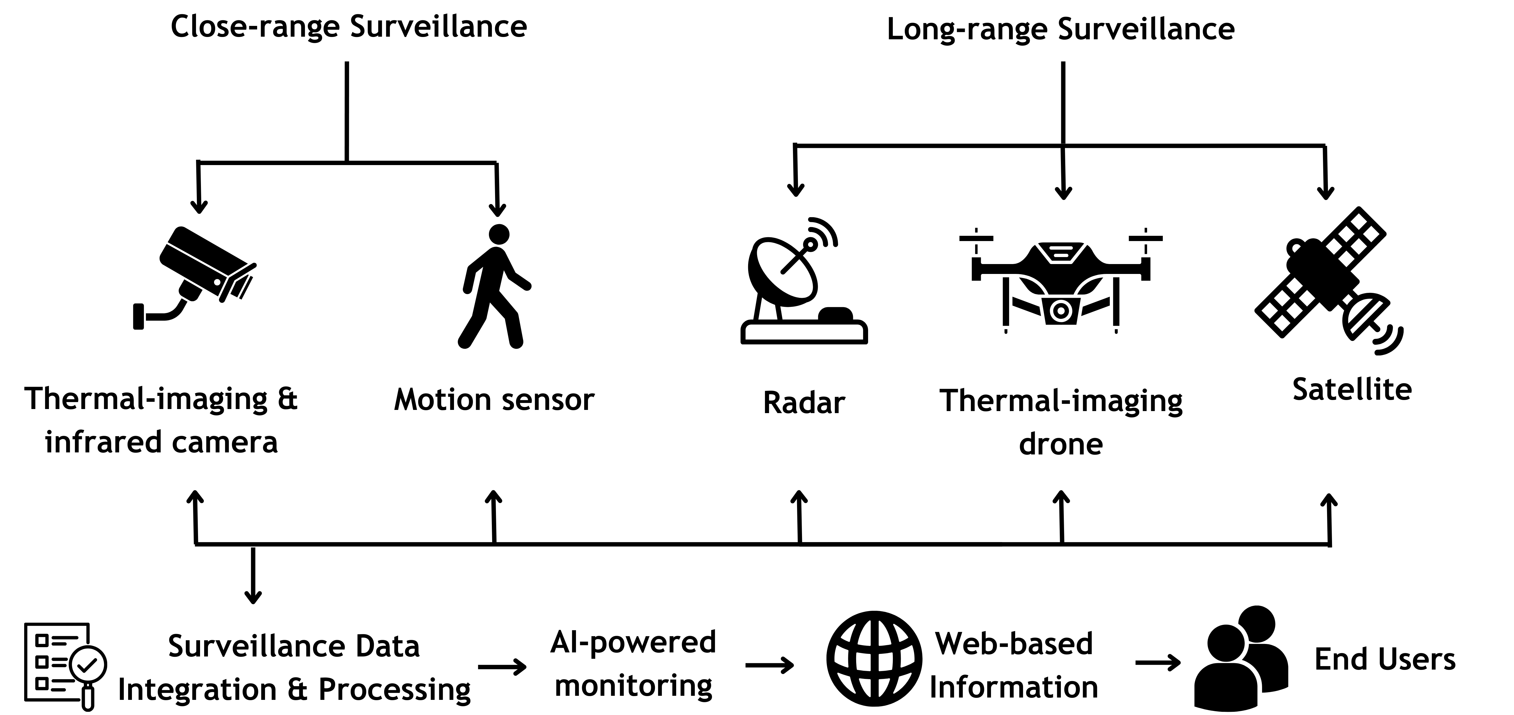
Figure 3. Technology-based Surveillance System

Figure 3 contains a surveillance system for Indonesian border management that utilizes technological advances. The new system can overcome challenges in the security surveillance sector because the integration of these technologies allows for continuous security surveillance from easily accessible areas to geographically isolated areas. Close-range surveillance is strengthened by the presence of cameras equipped with thermal-imaging and infrared sensors that can see conditions in all conditions, including low visibility. Motion sensors are also installed to be paired with surveillance cameras to detect movements that occur in border areas. These cameras and sensors are installed at border posts, watchtowers, and the like along the border. The integration of these two technologies ensures that surveillance can be carried out continuously in all conditions.
Long-range surveillance is strengthened by the use of radar, thermal-imaging drones, and satellites to monitor areas that are difficult to reach by traditional patrols. The characteristics of radar that do not depend on light make it very suitable for long-range surveillance because it can be done day and night. The working concept of a thermal-imaging drone is the same as a thermal-imaging camera in close-range surveillance, namely by detecting temperature in the border area. The difference is that drones have a much longer range. Satellites are used to see how the terrain changes in the border area. The spatial and temporal coverage of satellites is the widest of the available options. This factor provides great potential for use in border area surveillance.
Data from these surveillances are then collected in a database to be analyzed using AI assistance. This analysis is important to see how activity trends in the border area are to help policy making. The results of the analysis are then displayed on a special website so that they can be accessed by users, both agencies and the general public.

Conclusions
Indonesia faces complex issues in managing its land borders with neighbouring countries, such as weak law enforcement. The harsh geographical conditions of border areas provide additional challenges in border management. These issues have resulted in many spaces being exploited by irresponsible parties to commit cross-border crimes.
There are quite a few border areas in Europe that have the same problems as Indonesia, so European countries have made many efforts to overcome these issues. Indonesia can learn from European countries about how they resolve these issues from four perspectives: legal and institutional framework, security surveillance, cross-border economic development, and diplomatic engagement. Adaptation and utilization of technology have become the vanguard in resolving border issues in European countries.
Digital transformation in Indonesia's border management could be a viable option to try so that border issues can be resolved immediately. The use of cutting-edge short and long-range surveillance technology will greatly assist Indonesia in seeing the condition of its border areas in real-time. The integration of AI into digital reform will also be a very good breakthrough because AI can help analyze surveillance data comprehensively. This digital reform also ensures transparency in the development of information on Indonesia's border areas because all parties, from the government to the general public, will have a centralized and easily accessible web-based information system.
Feasibility studies on the implementation of these technologies in Indonesia's border areas are needed in future research directions. The existence of such studies will provide a clear picture of what needs to be done and how the implementation of these technologies will impact the effectiveness of Indonesia's border management. In addition, digital reform that is highly dependent on the internet really needs a competent cybersecurity concept considering the possibility of limited information about Indonesia's border areas that can only be accessed by a few parties.

References

Aammari, L. (2020). Rashid Khalidi.- The Hundred Years’ War on Palestine: A History of Settler Colonialism and Resistance, 1917-2017 (New York: Metropolitan Books, 2020), 336 p.
Armita Arvanti, Bayu Setiawan, Syamsunasir, S., & Pujo Widodo. (2023). Dynamics of Border Conflict Resolution Between Indonesia-Timor Leste. International Journal Of Humanities Education and Social Sciences (IJHESS), 3(1), 157–166. https://doi.org/10.55227/ijhess.v3i1.579
Budi, G., & Ratmono, B. M. (2018). Perspectives on the Development of Border Regions in Indonesia. Research on Humanities and Social Sciences, 8(6), 1–6.
Davis, R. (2019). Indonesia, and Timor-Leste Sign Agreement on Cross-Border Trade and Cooperation. Retrieved from Asian Development Bank (ADB) website: https://www.adb.org/news/adb-indonesia-and-timor-leste-sign-agreement-cross-border-trade-and-cooperation
Fachri, Y. (2015). KEBIJAKAN PEMERINTAH INDONESIA DALAM PENGELOLAAN WILAYAH PERBATASAN (STUDI KASUS PERBATASAN INDONESIA DAN MALAYSIA). Politik, Birokrasi Dan Perubahan Sosial Ke-II “Pilkada Serentak, Untung Rugi Dan Korupsi Politik,” 2015.
Febrica, S. (2014). Securing the Sulu-Sulawesi Seas from Maritime Terrorism: a Troublesome Cooperation? Perspectives on Terrorism, 8(3), 64–83.
Firdaus, F. (2019). Dampak kebijakan pembangunan Pos Lintas Batas Negara (PLBN) Aruk di Desa Sebunga Kabupaten Sambas, Kalimantan Barat. Jurnal Ilmiah Ilmu Pemerintahan, 3(2), 109. https://doi.org/10.14710/jiip.v3i2.3881
Gorzelak, G. (2016). Normalizing Polish-German relations: Cross-border cooperation in regional development. In EU Enlargement, Region Building and Shifting Borders of Inclusion and Exclusion (pp. 195–205). Routledge.
Hildebrandt-Wypych, D. (2022). Contrasting Narratives of the Israeli-Palestinian Conflict in Polish History Textbooks. Frontiers in Education, 7(March), 1–13. https://doi.org/10.3389/feduc.2022.815830
Huss, M., Hock, R., Bauder, A., & Funk, M. (2010). 100-year mass changes in the Swiss Alps linked to the Atlantic Multidecadal Oscillation. Geophysical Research Letters, 37(10).
İNAÇ, H. (2024). Üds Sosyal B İ L İ Mler Ek İ M 2009 1. - 18. Journal of Society, Economics, and Management, 5(312), 0–2.
Jade, E. (2022). EVALUASI USABILITY SISTEM BORDER CONTROL MANAGEMENT DENGAN METODE SYSTEM USABILITY SCALE DI TEMPAT PEMERIKSAAN KEIMIGRASIAN MOTAAIN. Jurnal Komputer Dan Informatika, 10, 129–136. https://doi.org/10.35508/jicon.v10i2.7936
Kennedy, P. S. J. (2021). PENGELOLAAN WILAYAH PERBATASAN NEGARA REPUBLIK INDONESIA. In Sustainability (Switzerland) (Vol. 11).
Khan, S., & Shameem, A. (2024). BORDERS AT THE MARGINS: LIVED EXPERIENCES AND GOVERNANCE CHALLENGES OF BORDER COMMUNITIES IN JAMMU AND KASHMIR. ShodhKosh: Journal of Visual and Performing Arts, 5. https://doi.org/10.29121/shodhkosh.v5.i5.2024.2569
Krumiņš, T. (2017). Arbitration in Latvia: A cautionary tale? Journal of International Arbitration, 34(2), 303–331. https://doi.org/10.54648/joia2017016
Leonita, K., Tawa, W., Daniel, R., Neves, D., Meta, Y. O., Djoka, N. B., & Arman, Y. (2024). PENYELUNDUPAN BBM KE TIMOR LESTE DI PERBATASAN TTU. 8(7), 668–677.
Liverman, D., Varady, R., Chavez, O., & Sanchez-Rodriguez, R. (1999). Environmental issues along the United States-Mexico border: Drivers of change and responses of citizens and institutions. Annual Review of Energy and The Environment - ANNU REV ENERG ENVIRON, 24, 607–643. https://doi.org/10.1146/annurev.energy.24.1.607
Mangku, D. G. S. (2019). Peran Badan Nasional Pengelolaan Perbatasan (BNPP) Dalam Menjaga Kedaulatan Wilayah Negara Kesatuan Republik Indonesia. Jurnal Ilmiah Ilmu Sosial, 4(2), 167–174. https://doi.org/10.23887/jiis.v4i2.16532
Mangku, D. G. S. (2020). Agreement Between Indonesia - Timor Leste In The Resolution Of The Land Border Dispute. Jurnal IUS Kajian Hukum Dan Keadilan, 8(30).
Maria Vianey Gunu Gokok, Tanti Nurgiyanti, Diansari Solihah Amini, & Yeyen Subandi. (2023). Peran Pos Lintas Batas Negara Motamasin dalam Mengatasi Imigran Ilegal di Wilayah Perbatasan RI-RDTL. SOSMANIORA: Jurnal Ilmu Sosial Dan Humaniora, 2(1), 54–59. https://doi.org/10.55123/sosmaniora.v2i1.1695
Marin, L., & Krajčíková, K. (2016a). Deploying Drones in Policing Southern European Borders: Constraints and Challenges for Data Protection and Human Rights. In Drones and Unmanned Aerial Systems (pp. 101–127). https://doi.org/10.1007/978-3-319-23760-2
Marin, L., & Krajčíková, K. (2016b). Deploying Drones in Policing Southern European Borders: Constraints and Challenges for Data Protection and Human Rights. https://doi.org/10.1007/978-3-319-23760-2_6
Missbach, A. (2014). Doors and fences: Controlling Indonesia’s porous borders and policing asylum seekers. Singapore Journal of Tropical Geography, 35. https://doi.org/10.1111/sjtg.12059
Niode, B., Rachman, I., & Waworundeng, W. (2022). Implikasi Border Crossing Agreement dan Border Trade Agreement Terhadap Konektivitas di Wilayah Perbatasan Indonesia-Filipina. Intermestic: Journal of International Studies, 7, 207. https://doi.org/10.24198/intermestic.v7n1.10
Nowak, K., Olszańska, A., Pietrzyk-Kaszyńska, A., Giergiczny, M., Niedziałkowski, K., Simonienko, K., & Jaroszewicz, B. (2025). Border militarization affects people’s interactions with nature in Białowieża Forest. Ambio, 54(2), 175–183. https://doi.org/10.1007/s13280-024-02113-5
Pedrozo, S. (2017). Swiss military drones and the border space: a critical study of the surveillance exercised by border guards. Geographica Helvetica, 72(1), 97–107. https://doi.org/10.5194/gh-72-97-2017
Permatasari, A. (2014). Otonomi Khusus Daerah Masalah Perbatasan. Jurnal Media Hukum, 21(2), 225–240.
Putra, A. (2015). Hubungan Kerjasama Perbatasan Indonesia-Malaysia (Studi Kasus Perbatasan Nunukan-Tawau). Jurnal Hukum IUS QUIA IUSTUM, 22(2), 308–326. https://doi.org/10.20885/iustum.vol22.iss2.art8
Redjo, S. I., & As’ari, H. (2017). Pengelolaan Pemerintah dalam Pengaturan Pulau-Pulau Kecil Terluar Indonesia. Jurnal Agregasi : Aksi Reformasi Government Dalam Demokrasi, 5(2). https://doi.org/10.34010/agregasi.v5i2.445
Rokhanyah, H., Noor, M. I. N., Harahap, A. M., Wijaya, B. S., & Amalia, N. R. (2023). Kolaborasi Kebijakan Pemerintah dalam Mengurangi Penyelundupan di Daerah Perbatasan (Studi Kasus Republik Indonesia & Republik Demokratik Timor Leste). Jurnal Pemerintahan Dan Politik, 8(4), 305–313. https://doi.org/10.36982/jpg.v8i4.3386
Sari, U. C., & Rahman, B. (2019). Studi Literatur: Kajian Geoteknik Daerah Perbatasan sebagai Salah Satu Faktor dalam Penguatan Infrastruktur Daerah Perbatasan di Kabupaten Belu, Nusa Tenggara Timur. Jurnal Planologi, 16(1), 32. https://doi.org/10.30659/jpsa.v16i1.4320
Sarjono, F., & Rudiatin, E. (2022). Informal Cross-Border Trade: Malaysia-Indonesia Borders The Conceptualisation From ‘Authority-Defined’ To “Everyday-Defined.” BASKARA : Journal of Business and Entrepreneurship, 5(1), 108–122. https://doi.org/10.54268/baskara.5.1.108-122
Schmidtke, O. (2023). Competing Historical Narratives: Memory Politics, Identity, and Democracy in Germany and Poland. Social Sciences, 12(7). https://doi.org/10.3390/socsci12070391
Seran, G. G. (2022). Penguatan Kelembagaan Pengelolaan Perbatasan Negara. Jurnal Sosial Humaniora, 13(1), 39–55. https://doi.org/10.30997/jsh.v13i1.4833
Sholikah, D. I. (2020). Analisis Penyelesaian Perbatasan Laut Antara Peru dengan Chili yang Diselesaikan Oleh Mahkamah Internasional (ICJ). Jurnal Hukum Lex Generalis, 1(1), 25–34. https://doi.org/10.56370/jhlg.v1i1.195
Slack, J., & Martinez, D. (2019). The Geography of Migrant Death: Violence on the US-Mexico Border. https://doi.org/10.4337/9781786436030.00020
Sudiar, S. (2015). Pembangunan Wilayah Perbatasan Negara: Gambaran Tentang Strategi Pengelolaan Kawasan Perbatasan Darat di Provinsi Kalimantan Utara. Jurnal Administrative Reform, 3(4), 489–500.
Świerczyńska, J. (2023). The importance of border surveillance and border traffic control at The Eastern Border of The Republic of Poland to the cross-border security of The European Union. Central European Review of Economics & Finance, 44(3), 153–174.
Tasik, Y., Setiawan, A. A., Widirahayu, M. D. A., & Saleh, M. M. (2023). Sengketa Perbatasan Sino-India Dalam Kepentingan Geopolitik Tiongkok (Studi Kasus Terhadap Konflik Perbatasan Pada Line Of Actual Control Tahun 2020). Jurnal Pendidikan Dan Konseling, 5(1), 4833–4839.
Tholens, S. (2017). Border management in an era of ‘statebuilding lite’: Security assistance and Lebanon’s hybrid sovereignty. International Affairs, 93(4), 865–882. https://doi.org/10.1093/ia/iix069
Toribio, A. J. (2023). Protecting Rights at Borders: Policy Note III. In European Programme for Integration and Migration (Vol. 3).
Ulut, N. G. R., Amitran, P. Y., & Foenay, C. C. (2023). Analisis Pemberdayaan Umkm Terhadap Pendapatan Masyarakat Lokal Di Wilayah Lintas Batas Atambua-Timor Leste. Hurnal Ekonomi & Ilmu Sosial, 4(5), 1171–1186.
Uly, H., Harsono, G., Supriyatno, M., & Gultom, R. A. G. (2023). Strategi Pertahanan Negara dalam Mengamankan Wilayah Perbatasan di Indonesia (Studi Kasus Perbatasan Indonesia-RDTL). Journal on Education, 5(3), 7508–7521. https://doi.org/10.31004/joe.v5i3.1543
van Zundert, A. A. J. (2022). Volume 05 Issue 02 February 2022. International Journal of Social Science and Human Research, 05(02).
Verma, R. (2024). India – China rivalry , border dispute , border ﬆandoffs , and crises. India Review, 23(5), 397–408. https://doi.org/10.1080/14736489.2024.2423996
Zampieri, M., Scoccimarro, E., Gualdi, S., & Navarra, A. (2015). Observed shift towards earlier spring discharge in the main Alpine rivers. Science of the Total Environment, 503, 222–232.

