THE IMPLEMENTATION OF SOMALIA’S FOREIGN POLICY WITH CHINA MILITARY INVOLVEMENT IN FACING THE PIRACY (2008-2024)
CASE STUDY: GULF OF ADEN AND SOMALIA SEA

Lia Aulia Lubis¹, Afri Emilia Br Sembiring², Anak Agung Banyu Perwita³

UPN VETERAN JAKARTA UNIVERSITYA¹, SATYA WACANA CHRISTIAN UNIVERISTY², REPUBLIC OF INDONESIA DEFENSE UNIVERSITY³
(liaulialubis@gmail.com, afriemilia.s@gmail.com, aabanyu.perwita@gmail.com)

Abstract
Somalia, with its strategic location in the Horn of Africa and extensive coastline, faces persistent challenges of piracy despite its potential as a regional maritime hub. The collapse of Somalia's government in 1991 created a power vacuum that fueled piracy, adversely affecting international trade and regional stability. This study examines the implementation of Somalia’s foreign policy with China's military involvement to combat piracy in the Gulf of Aden and Somali Sea from 2008 to 2024. Using a case study approach, it analyzes domestic and international factors influencing policy decisions, including Somalia's internal instability, economic collapse, and regional maritime dynamics. China's role, through its People’s Liberation Army Navy (PLAN), highlights a strategic partnership focused on protecting key maritime routes and enhancing Somalia’s maritime security. Over 15 years, PLAN operations have evolved from protection-focused missions to joint patrols and multilateral exercises, significantly reducing piracy incidents. The collaboration has also supported Somalia's economic growth and regional stability, aligning with China's Belt and Road Initiative objectives. Despite these successes, the resurgence of piracy in 2024 underscores ongoing challenges, necessitating sustained international cooperation and adaptive strategies. This research concludes that Somalia's foreign policy, leveraging China's military and economic aid, demonstrates a pragmatic approach to safeguarding national interests and fostering regional stability. It highlights the interplay of internal vulnerabilities and global geopolitical strategies in addressing complex security issues, offering insights into the role of military diplomacy in international relations.
Keywords: China, Foreign Policy, Maritime Security, Piracy, Somalia

Introduction
Somalia is a country located in the Horn of Africa and holds a strategic geographical position in the easternmost part of the continent. Somalia shares borders with Ethiopia to the west, the Gulf of Aden to the north, the Somali Sea and the Guardafui Channel to the east, and Kenya to the southwest.
Somalia’s position gives this country of significant access to key maritime routes and neighboring countries (Rondos, 2016). One of Somalia's most notable features is its extensive coastline, which stretches for 3,025 kilometers (Carbone & Accordi, 2000). This makes it the longest coastline on mainland Africa, giving the country a vital role in regional maritime activities and access to some of the most important shipping lanes in the world.
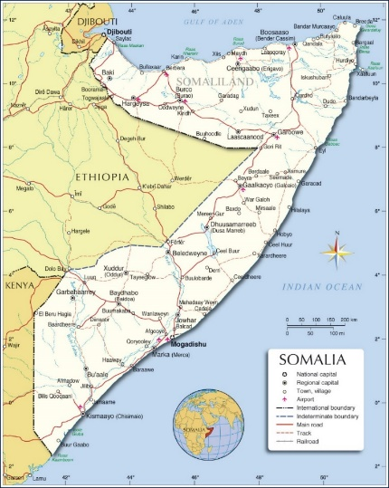
Figure 1. Map of Somalia
Somalia has experienced prolonged armed conflict and political instability since the collapse of its central government in the early 1990s. This ongoing instability has stifled economic growth and rendered large parts of the country unsafe for business activities. Much of Somalia's economy operates informally, with key sectors such as trade, fishing, and agriculture forming the backbone. Somalia is highly dependent on international aid to meet basic needs and fund development, which, while crucial for economic stabilization, also leaves the country vulnerable to changes in international policy. Despite these challenges, Somalia's strategic location in the Horn of Africa gives it the potential to become a hub for maritime trade. However, the threat of piracy off the Somali coast has damaged the country's reputation as a safe trade route.
Despite having the longest coastline in Africa, Somalia's maritime and related economic security protection remains underdeveloped. The coastline presents many commercial and strategic opportunities but also associated national security risks, including arms and human trafficking, piracy, and as a channel for terrorists to move arms and personnel from the Middle East to the Horn of Africa (The Ministry of Planning, 2024). From economic and environmental perspectives, the risks include illegal foreign fishing activity, the dumping of toxic waste, and unregulated economic activity. In addition, piracy off the coast of Somalia has raised the costs of shipping, presented grave physical risks, and has damaged Somalia's commercial opportunities to exploit a globally strategic shipping route and rich fish stocks. The Federal Government of Somalia (FGS) has recognized the importance of marine security and has designated the territorial waters of Somalia, the continental shelf, Exclusive Economic Zone, demarcation and matters related to the Red Sea as matters of national security (UNSOM and the World Bank, 2017).
In order to protect their national security, including economi and maritime, Somalia is having several cooperation both bilateral and multilateral with many countries, which one of them is China. The rise of piracy in Somalia can be attributed to a combination of social and economic factors that have created a conducive environment for such activities. The collapse of the Somali government in 1991 resulted in a disintegration of state functions, leaving a void where law and order no longer existed. This vacuum allowed piracy to emerge as a survival strategy in the absence of a functioning government capable of providing security or basic services. Contributing further to the problem is the pervasive poverty and high unemployment rate in Somalia, particularly among the youth, with 67% of young people jobless (Karawita, 2019). The dire economic situation makes piracy an appealing alternative for many young Somali men desperate to improve their livelihoods. The lack of legitimate economic opportunities has also led many to see piracy as a viable path to financial success, with the profits often shared within communities, incentivizing participation. Somali social dynamics, which emphasize community support and sharing, further reinforce piracy as an accepted means of income, as wealth generated from these activities is typically redistributed among clan members. Corruption and organized crime also play a significant role in perpetuating piracy, with organized syndicates providing the resources and technology needed to sustain these operations, often through money laundering and other illicit activities.
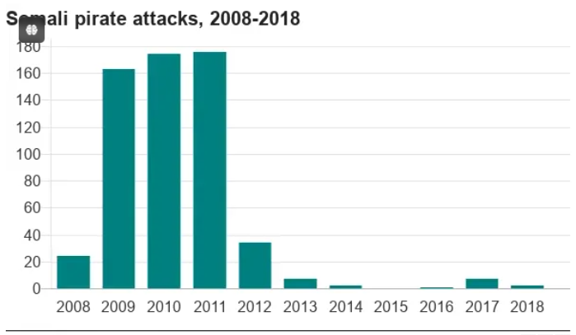
Figure 2. Piracy in Somalia Trends (BBC, 2019)
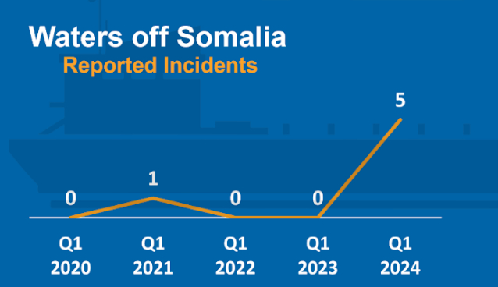
Figure 3. Piracy in Somalia Q1 2020-2024 (The International Chamber of Commerce, 2024)
Pirate attacks in Somalia started at least in 2008 and peaked in 2011 but have declined to negligible levels in recent years. Unfortunately, after several years decrease, in 2024, there was an attack of Somali pirate to Bangladesh's ships in the Indian Ocean (Arbar, 2024). The renewed activity of Somali pirates is concerning, making it more important than ever to protect trade, secure shipping routes, and ensure the safety of the seafarers who keep global commerce running. It is essential to take all necessary steps to maintain the continuous and uninterrupted flow of goods through international supply chains (The International Chamber of Commerce, 2024). Especially now, when the Somalia’s economic seems to be growing. Somalia’s country known has poverty declined from 69% in 2021 to 54.4% in 2022, while youth unemployment remained high at 30.1% in 2022, well above the 21.7% overall unemployment rate.
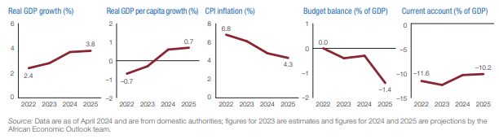
Figure 4. Somalia's Economic Outlook (African Development Bank Group, 2024)
Therefore, this paper aims to analyse the implementation of Somalia’s foreign policy with China’s military involvement in facing the piracy in the Gulf of Aden and Somali Sea. This paper is important with the rise of China or the phenomenon of China's increasing global influence in recent decades, not only in terms of economy, but also military, in order to “help” Somalia.

Research Methods
This research employs a qualitative approach, utilizing a case study methodology to analyze the implementation of Somalia's foreign policy with China's military involvement in addressing piracy. The research began with a comprehensive literature review, which included academic journals, government reports, and international publications to establish a theoretical framework and contextualize Somalia's maritime challenges and China's role.
Data collection focused on secondary sources, including official government documents, United Nations resolutions, and reports from international organizations such as the International Maritime Organization (IMO) and the African Development Bank. Credible news agencies and historical records of piracy incidents were also used to provide relevant insights. The collected data was analyzed using content analysis to identify themes such as the evolution of China's military strategy, the socio-economic impact of piracy on Somalia, and the role of multilateral cooperation. The case study focused on the Gulf of Aden and Somali Sea to provide a detailed examination of the bilateral and multilateral efforts against piracy, highlighting practical applications of foreign policy and defense diplomacy.
The findings were evaluated for reliability and validity by cross-referencing multiple data sources and aligning them with established theoretical frameworks in maritime security and international relations. This methodological approach ensures a thorough understanding of the research problem and provides a solid foundation for assessing the effectiveness of Somalia's foreign policy in collaboration with China to combat piracy.

Results and Discussion
Case Study
Somalia and China established their diplomatic relations on December 14, 1960 (Shengchao, 2011). Due to into civil conflicts in Somalia on around 1991, China has always supported and actively promoted the peace process in Somalia, and served as the UN Security Council (UNSC) coordinator in Somalia from 2003 to 2007. Not only that, in line with relevant UNSC resolutions, since December 2008, the Chinese government has dispatched naval ships to carry out regular vessel protection operations in the Gulf of Aden and the waters off the coast of Somalia. China’s PLAN (People's Liberation Army Navy) task groups cooperate with multiple naval forces in the area to safeguard international Sea Lines of Communication (SLOCs). Over the past decade, the PLA Navy has regularly deployed over 100 vessels and 26,000 officers and sailors in 31 convoys, each consisting of three to four ships. These convoys have been instrumental in providing security protection for numerous ships (Xinhua, 2023).
China's military involvement in combating piracy in the Gulf of Aden and the Somali Sea has began in 2008 when China deployed its People's Liberation Army Navy (PLAN) to the Gulf of Aden to counter the rising threat of piracy off the coast of Somalia (Cheng, 2019). This deployment marked the first time China's navy engaged in an operational mission outside its claimed territorial waters (Kaufman, 2009) (Kamerling & Van Der Putten, 2011). The Chinese naval forces cooperated with international naval forces, including those from the United States, Japan, and Russia, in anti-piracy operations, reflecting a shift in Chinese foreign policy towards more military operations other than war (MOOTW) (Christoffersen, 2009). Initially, the primary objective was to protect Chinese shipping interests against piracy. However, over time, the deployment evolved to contribute to the development of a blue-water navy capable of projecting power in the Far Seas, enhancing power projection capability, acquiring Far Seas experience, and improving China's image in the region (Henry, 2016). The deployment in the Gulf of Aden is part of China's broader strategy to secure national economic interests, particularly the sea lines of communication (SLOCs) vital for the export market and energy supply, aligning with China's Maritime Silk Road initiative aimed at increasing its influence in the region (Henry, 2016). The experience gained from anti-piracy operations in the Gulf of Aden has been instrumental in the modernization of the PLAN, helping China develop a power projection capability and expand its naval reach towards the Indian Ocean, contributing to its rise as a maritime power (Henry, 2016). Additionally, China's participation in anti-piracy operations has been viewed as an indication of its willingness to take on a larger military role on the global stage, impacting its relations with other nations, particularly the United States, and reflecting a growing interest in international maritime security (Kaufman, 2009).
In carrying out foreign policy, countries often engage in international interactions and cooperation based on the principle of mutual benefit. This principle, known as reciprocity, is an important basis in bilateral and multilateral relations, including in the context of cooperation between Somalia and China in facing the challenges of piracy in the Gulf of Aden and the Somali Sea that also related to the national interests of both contries.
From Somalia's perspective, the country has an urgent need to enhance security in its waters, particularly due to the high threat of piracy in the Gulf of Aden and the Somali Sea. By allowing the People's Liberation Army Navy (PLAN) of China to operate in its waters, Somalia has gained direct benefits in maritime security, which has significantly helped reduce incidents of piracy. This not only improves the safety of vessels passing through its waters but also contributes to greater stability in the region, which is crucial for economic and social development. Additionally, as a country still struggling with the effects of prolonged conflict, Somalia greatly requires international assistance. China's involvement is not limited to the military sector but also includes economic support and infrastructure development, such as investments in essential infrastructure like ports and roads, which are vital for Somalia's economic recovery. This cooperation also provides Somalia with access to the technical and humanitarian aid needed to support its population. Furthermore, collaboration with China offers Somalia an advantage in terms of international recognition. By forging close ties with a major power like China, Somalia can elevate its profile on the international stage, attracting more support from other countries and international organizations for various development and security initiatives.
On the other hand, from China's perspective, military involvement in the Gulf of Aden and the Somali Sea is part of a broader strategy to protect vital maritime routes that connect Asia, Europe, and Africa. These routes are crucial for global trade, including energy supplies that are the backbone of China's economy. By securing these routes from the threat of piracy, China not only safeguards its economic interests but also strengthens its position as a global maritime power. China's involvement in this region also reflects its ambition to become a more significant global power. By deploying its navy in strategic areas like the Gulf of Aden, China can project its power beyond its territorial waters, a crucial step in developing a "blue-water navy" capable of long-range operations. This enables China to extend its influence not only in Africa but also on a broader global scale. Moreover, China's military involvement in the Gulf of Aden aligns with the Maritime Silk Road initiative, part of the broader Belt and Road Initiative (BRI), aimed at enhancing global economic and infrastructure connections linked to China.
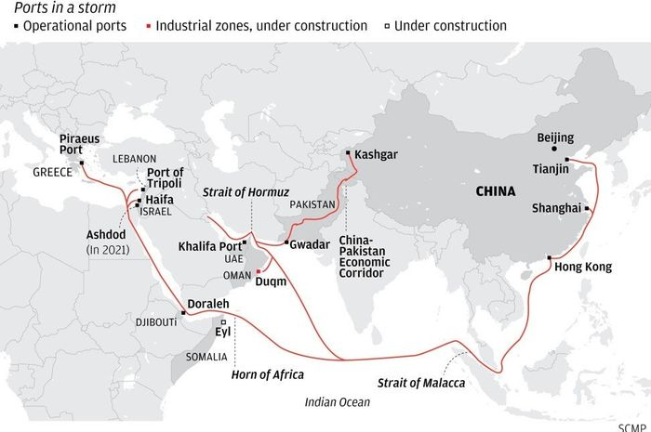
Figure 5. BRI Routes (South China Morning Post)
As seen on the figure 5, the routes of BRI by China is pass through the Gulf of Aden, while they have a port on Doraleh. Furthermore, by contributing to stability in this strategic region, China try to ensure that the BRI projects can proceed without significant obstacles, thereby increasing its economic influence across a wider region.

The Implementation of Somalia’s Foreign Policy with China Military Involvement in Facing the Piracy (2008-2024) – Case Study: Gulf of Aden and Somalia Sea
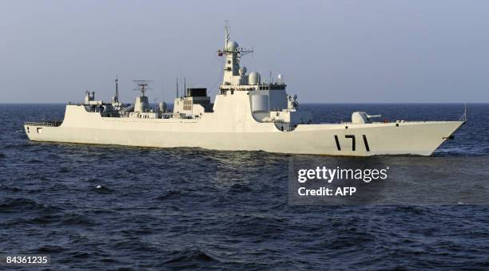
Figure 6. The People's Liberation Army Navy first anti-piracy operation took place in the Gulf of Aden on 6 January 2009

PLAN’s Evolving Approach to Piracy in the Gulf of Aden
The People's Liberation Army Navy (PLAN) has significantly evolved its approach to addressing the threat of piracy in the Gulf of Aden since its initial involvement in 2009. Each phase of this evolution reflects how PLAN has adjusted its strategies and tactics to meet the increasingly complex challenges of maintaining maritime security in one of the world’s most strategic shipping lanes (Erickson & Mikolay, 2009).
This approach continued through 2011, focusing on ensuring the safety of merchant vessels. In 2012, PLAN adopted more assertive measures, including simulated assaults and warning shots, marking a shift toward a more proactive stance.
From 2013 to 2015, PLAN increased its focus on international cooperation, engaging in joint exercises and information sharing with other navies, thereby strengthening its role in global maritime security. By collaborating with other nations, PLAN not only expanded the scope of its operations but also demonstrated China’s commitment to international stability and security (Henry, 2016).
Since 2016 to the present, PLAN has continued to refine its tactics based on the operational experiences it has gained. PLAN has begun employing a combination of intimidation and direct action during escort missions, reflecting a broader understanding of the complexities of maritime security. This evolution reflects PLAN's deepening understanding of maritime security complexities and its commitment to a more comprehensive and adaptive strategy in the Gulf of Aden (Henry, 2016).

Domestic or Internal Factors
The domestic factors in Somalia are significant in explaining why the country has become a hub for maritime piracy, particularly in the strategically important waters of the Gulf of Aden. Somalia's geographical location, near one of the busiest maritime trade routes in the world, the Gulf of Aden, is a significant factor. This route connects the Indian Ocean to the Red Sea and the Suez Canal, making it a vital corridor for international trade. However, Somalia's extensive coastline, stretching approximately 3,025 kilometers, is extremely difficult for local authorities to monitor and control. This situation gives pirates a tactical advantage, allowing them to operate easily, hide, and escape after launching attacks. Additionally, Somalia borders countries that also face maritime security challenges, such as Yemen, further increasing the region's vulnerability to criminal activities, including piracy (Potgieter, 2008).
The political and security instability that has plagued Somalia since the fall of Siad Barre's regime in January 1991 exacerbates this situation. The prolonged civil war and clan conflicts have created deep political instability, resulting in the central government's weakened ability to control its own territory. The government's inability to enforce laws and maintain security has created a power vacuum that pirate groups have exploited to thrive. As a result, the lack of effective authority enables pirates to operate relatively freely, without fear of repressive action from the government (Elmi & Barise, 2006).
Furthermore, Somalia's collapsed economy is a major factor driving individuals to engage in criminal activities such as piracy. A significant portion of the Somali population lives in extreme poverty, with little or no access to decent employment opportunities. In a situation where livelihoods are hard to come by, many people, particularly the youth, see piracy as the only means of survival. Corruption within the government exacerbates this situation, as corrupt officials either facilitate or, at the very least, do not hinder illegal activities (Djama, 2011).
The breakdown of social and legal structures in Somalia is also important in the proliferation of piracy. The absence of a functioning legal system means there is no effective law enforcement to prevent or punish acts of piracy. In some cases, traditional clan structures even support or do not obstruct pirate activities, viewing them as a way to protect or benefit their communities. This creates an environment where the law holds little power, allowing pirates to operate with impunity (Guilfoyle, 2009).
Finally, the exploitation of marine resources by foreign fishermen engaged in illegal fishing in Somali waters further aggravates the situation. This exploitation depletes marine resources, which are the primary livelihood for many coastal communities. As these vital natural resources diminish, anger grows, pushing some groups to retaliate by hijacking foreign ships. This cycle of violence and crime perpetuates itself, deepening the instability in the region (Glaser et al., 2019).

External Factors
External factors are significant in understanding the dynamics of piracy in Somali waters. The international system and regional sub-system are instrumental in shaping global and regional frameworks and responses to this threat. These two systems are interconnected in global and regional efforts to address piracy and ensure ongoing security and stability in these strategic waters.

International System
- Global Maritime Security
The waters around Somalia, particularly the Gulf of Aden and the western Indian Ocean, are among the most vital international trade routes in the world. This route connects the Indian Ocean with the Red Sea and the Suez Canal, serving as a key passage for ships transporting goods between Asia and Europe. Consequently, maritime security in this region is crucial for the smooth flow of global trade (He et al., 2023). Any disruption in these waters, such as piracy, can have wide-reaching economic impacts, harming many countries. To address this threat, numerous nations, including China, participate in multinational operations such as Combined Task Force 151, as well as NATO and EU NAVFOR operations, all designed to maintain security and suppress piracy in Somali waters. China's involvement in these operations demonstrates its commitment to supporting global stability and protecting international maritime interests (Schwarz, 2012).

- China's Role on the Global Stage
As an increasingly dominant global power, China has a significant interest in strengthening its position on the international stage, particularly concerning global security issues. China's involvement in efforts to maintain maritime security off the coast of Somalia is part of a broader strategy to demonstrate its leadership in addressing global security challenges. By actively participating in anti-piracy operations, China not only protects its economic interests linked to maritime trade routes but also increases its image as a responsible nation contributing to global peace and stability (Kamerling & Van Der Putten, 2011).
- International Cooperation Framework
International efforts to combat piracy off the coast of Somalia are closely tied to the framework of international cooperation facilitated by global organizations. The UN Security Council, for example, has issued several resolutions encouraging member states to collaborate in addressing the piracy problem. As a permanent member of the Security Council, China has both a moral and political obligation to support the implementation of these resolutions. China, along with other nations, works through international platforms such as the International Maritime Organization (IMO), which plays a key role in promoting maritime safety and security worldwide. This cooperation ensures that efforts to combat piracy are coordinated and effective, involving various countries and international organizations (Boamah, 2023).
- Bilateral and Multilateral Relations
Through direct cooperation with Somalia, China can help build Somalia's maritime security capacity, including training and providing equipment for the Somali navy and coast guard. This collaboration is often carried out within the framework of multinational operations such as Combined Task Force 151, NATO, and EU NAVFOR. By enhancing Somalia's ability to protect its own waters, China contributes to a more sustainable solution to piracy and strengthens regional security (Schwarz, 2012).

Regional Sub-System
- Security in East Africa and the Horn of Africa
Maritime security in Somali waters impacts not only Somalia itself but also the regional stability of East Africa and the Horn of Africa. Countries in this region heavily rely on safe waters for their trade and economic sustainability. Piracy in Somali waters can disrupt trade activities, raise maritime insurance costs, and threaten the safety of ships and their crews (Potgieter, 2008). This has the potential to create broader instability in the region. In this case, China, through cooperation with countries in this region, including Somalia, plays a key role in collective efforts to enhance maritime security. This cooperation includes military training, joint patrols, and intelligence sharing aimed at strengthening the capacity of regional countries to face maritime threats. By helping to improve maritime security in this region, China contributes to regional stability and economic well-being (Schwarz, 2012).
- Regional Economic and Infrastructure Initiatives
Somalia is one of the countries involved in China’s global initiative, the Belt and Road Initiative (BRI). This initiative includes various infrastructure projects and investments aimed at enhancing connectivity and economic development in several countries, including those in East Africa and the Horn of Africa (Dianjaya, 2019). Maritime security is an important factor for the success of this initiative. China understands that stability in Somali waters is essential to ensuring the smooth progress of infrastructure projects under the BRI. Therefore, in addition to providing military assistance, China is also investing in infrastructure development in Somalia and its neighboring countries. These investments not only help improve local economic conditions but also serve as a preventive measure to reduce the factors that contribute to piracy, such as poverty and economic instability. Thus, China’s contributions to economic and infrastructure development in this region are an integral part of broader efforts to enhance regional security and stability (Demissie et al., 2019).

Decision Making Process
- President to President
In December 2008, a summit was held in Beijing where the President of Somalia and the President of China signed a joint statement reaffirming the commitment of both countries to cooperate in addressing piracy and promoting economic growth. This meeting was updated in December 2022 to reinforce the commitment.
- Ministry of Foreign Affairs to Ministry of Foreign Affairs
The Foreign Ministers of Somalia and China held a series of meetings in Mogadishu and Beijing to draft a Memorandum of Understanding (MoU) on maritime security cooperation and economic investment. This bilateral dialogue continues through regular video conferences and diplomatic visits. Both parties discussed the implementation of anti-piracy operations, economic aid, and infrastructure projects.
- Ministry of Defense to Ministry of Defense
Ministry of Defense to Ministry of Defense joint task force was established between the Somali Navy and the People's Liberation Army Navy (PLAN). This task force began conducting anti-piracy operations in January 2009 in the Gulf of Aden and Somali waters, including joint patrols and military exercises.
- Ministry of Economy to the Ministry of Commerce of China
Negotiations and the signing of a trade agreement in 2010 facilitated the export of Somali products to China and the import of high-tech goods and industrial equipment from China to Somalia. China also invested in the development of Mogadishu Port and the improvement of transportation infrastructure in Somalia to support trade and economic growth.

Impact of Maritime Cooperation between Somalia and China
- The implementation of maritime cooperation between Somalia and China, particularly through joint patrols and military operations in the Gulf of Aden and Somali waters, has been highly effective in reducing piracy incidents. From 2009 to 2018, the number of piracy attacks significantly decreased.
- The improvement in maritime security has had a direct and positive impact on Somalia's economy. Several critical factors contributed to a significant reduction in the poverty rate, which dropped from 69% in 2021 to 54.4% in 2022.
- Enhanced security in Somali waters not only benefits Somalia but also contributes to the broader stability of East Africa and the Horn of Africa.
- Safe maritime trade routes are essential for the global economy. The reduction in piracy incidents ensures that key routes, such as the Gulf of Aden, which connects the Indian Ocean with the Red Sea and the Suez Canal, remain open and secure for commercial shipping.
- China's economic assistance, including training and technology transfer, are significant in helping Somalia improve its industrial capacity and promote sustainable development.

Conclusions and Recommendations
Somalia's foreign policy, which invites foreign military involvement to combat piracy, especially from China, is influenced by a mix of internal and external factors. Since 1960, Somalia's relationship with China has grown, enhancing maritime security with also the support from several countries. China's participation successfully reduced piracy activities in Somalia through effective military operations and joint patrols from 2009 to 2018. Somalia's relationship with China is driven by shared interests in fighting piracy and enhancing regional stability. On the other hand, Somalia's national interests, such as protecting sovereignty, national security, and economic prosperity, are major reasons for seeking foreign military support. Internal factors influencing this policy include political and domestic security instability, a long and difficult-to-monitor coastline, and a collapsed economy. External factors include global maritime security and China's role on the world stage. As a dominant global power, China seeks to demonstrate its leadership in maritime security issues. International cooperation within the framework of UN Security Council resolutions encourages countries to collaborate in combating piracy in Somali waters. However, Somalia faces the challenge of piracy again with its resurgence in 2024, after several years of decline. China's military involvement is expected to continue strengthening Somalia's position in maintaining regional stability and combating pirates, making foreign military involvement a key part of Somalia's national security strategy.

References
Arbar, T. F. (2024). Bajak Laut Somalia “Bangkit dari Kubur”, Perdagangan Dunia Warning. CNBC Indonesia.
Boamah, F. (2023). The Role of the UN Security Council in the Fight Against Piracy in the Gulf of Guinea. Central European Journal of International and Security Studies, 17(3), 66–89. https://doi.org/10.51870/LQHU1305
Carbone, F., & Accordi, G. (2000). The Indian Ocean coast of Somalia. Marine Pollution Bulletin, 41(1–6), 141–159.
Cheng, C. (2019). China and U.S Anti-piracy Engagement in the Gulf of Aden and Western Indian Ocean Region (Issue 5).
Christoffersen, G. (2009). China and maritime cooperation: piracy in the Gulf of Aden. Asian Studies, 1–21. http://kms1.isn.ethz.ch/serviceengine/Files/ISN/111041/ipublicationdocument_singledocument/4066e301-cffa-4962-918a-75d5687d68fd/en/Piracy_Gulf_Aden.pdf
Demissie, A., Weigel, M., & Xiaonyang, T. (2019). CHINA’S BELT AND ROAD INITIATIVE & ITS IMPLICATIONS FOR AFRICA. WWF, VIII(July), 1–2.
Dianjaya, A. R. (2019). The Politics of Chinese Investment in Africa under Belt and Road Initiative (BRI) Project. Nation State Journal of International Studies, 2(2), 123–133. https://doi.org/10.24076/nsjis.2019v2i2.150
Djama, A. D. (2011). The phenomenon of Piracy off the Coast of Somalia: Challenges and Solutions of the International Community. Oceans and Law of the Sea-Divisions for Ocean Affairs and the Law of the Sea, 1(December), 1–3.
Elmi, A. A., & Barise, A. (2006). The Somali Conflict: Root causes, obstacles, and peace-building strategies. African Security Review, 15(1), 32–54. https://doi.org/10.1080/10246029.2006.9627386
Erickson, A. S., & Mikolay, J. D. (2009). The Chinese deployment to the Gulf of Aden is historic and significant. March, 40–41.
Glaser, S. M., Roberts, P. M., & Hurlburt, K. J. (2019). Foreign Illegal, Unreported, and Unregulated Fishing in Somali Waters Perpetuates Conflict. Frontiers in Marine Science, 6(December). https://doi.org/10.3389/fmars.2019.00704
Guilfoyle, D. (2009). Piracy off Somalia : a sketch of the legal framework. European Journal of International Law: Talk, i, 1–10.
He, Z., Wang, C., Gao, J., & Xie, Y. (2023). Assessment of global shipping risk caused by maritime piracy. Heliyon, 9(10), e20988. https://doi.org/10.1016/j.heliyon.2023.e20988
Henry, J. (2016). China’s Military Deployments in the Gulf of Aden: Anti-Piracy and Beyond. In Asie.Visions (Vol. 89, Issue November). https://globalmaritimehub.com/wp-content/uploads/attach_785.pdf
Kamerling, S., & Van Der Putten, F.-P. (2011). An Overseas Naval Presence without Overseas Bases: China’s Counter-piracy Operation in the Gulf of Aden. Journal of Current Chinese Affairs, 40(4), 119–146. https://doi.org/10.1177/186810261104000405
Karawita, A. K. (2019). Piracy in Somalia: An Analysis of the Challenges Faced by the International Community. Jurnal Ilmu Sosial Dan Ilmu Politik, 23(2), 102–119. https://doi.org/10.22146/JSP.37855
Kaufman, A. A. (2009). China’s Participation in Anti-Piracy Operations off the Horn of Africa: Drivers and Implications (Issue July).
Potgieter, T. (2008). the Maritime Security Quandary in the Horn of Africa Region : Causes , Consequences. East African Human Security Forum, January, 21. https://africacenter.org/wp-content/uploads/2016/01/The-Maritime-Security-Quandary.pdf
Rondos, A. (2016). The Horn of Africa. Horizons, 6, 150–160. https://doi.org/10.2307/3060223
Schwarz, M. (2012). ARMS TRANSFERS IN THE GULF OF ADEN Shining the “Spotlight” on Regional Dynamics. PEACE RESEARCH INSTITUTE FRANKFURT / LEIBNIZ-INSTITUT HESSISCHE STIFTUNG FRIEDENS- UND KONFLIKTFORSCHUNG.
Shengchao, H. E. F. (2011). Time and Distance Could Not Separate True Friends Like China and Somalia. Embassy of the People’s Republic of China in the Federal Republic of Somalia.
The International Chamber of Commerce. (2024). New report highlights continued threat of Somali piracy. Www.Icc-Ccs.Org.
The Ministry of Planning, I. and E. D. (2024). Somalia National Development Plan 2020 to 2024.
UNSOM and the World Bank. (2017). Federal Republic of Somalia Somalia Security and Justice Sector PER . International Bank for Reconstruction and Development.
Xinhua. (2023). Chinese navy’s 15-year quest for peace in Gulf of Aden, waters off Somalia. Chinadaily.Com.

